***Issue #11800***

***Issue #11800:*** *The shortcuts key (Ctrl++, Ctrl+-) would not work if input a large number as the font size on Themes Settings dialog.*

***Steps:***

***1.*** *Launch the Brackets*

***2.*** *Click View > Themes...*

***3.*** *Input a large number as the font size, such as "100px, 1000px..."*

***4.*** *Click Done*

***5.*** *Try to Press Ctrl++ and Ctrl+- to increase or decrease the font size*

***Result:*** *The shortcuts key doesn't work*

***Expect:*** *The shortcuts key could work normally*

*(*<https://github.com/adobe/brackets/issues/11800>*)*

***Requirements***

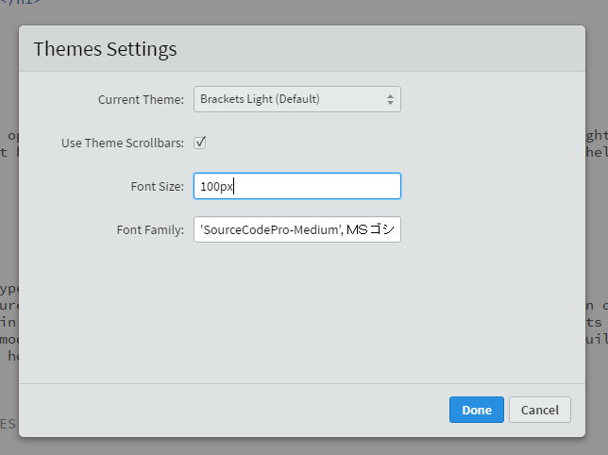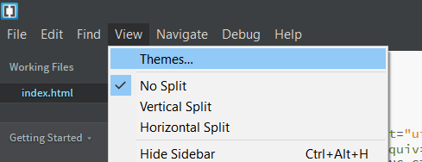The expected was the shortcuts keys Ctrl++ and Ctrl+- do zoom in and zoom out even though the font size on themes settings dialog is a large number, but they don’t.

The problem was that when you try to increase or decrease the font size, Brackets doesn't let you if the *new font size* is more than the *maxium font size* (72px) or less than the *minimum font size* (1px). Therefore, if the font size in themes settings is 100px and you try to decrease it pressing Ctrl+- nothing happens because the new font size will be 99px which is still more than 72px.

***Source Code Files***

**File involved with the issue:** /src/view/ViewCommandHandlers.js

**Code fragments involved the issue:**

* Declarations of the minimum and maximum font size in pixels:

*/\*\**

*\* @const*

*\* @private*

*\* The smallest font size in pixels*

*\* @type* **{number}**

*\*/*

var MIN_FONT_SIZE = 1;

*/\*\**

*\* @const*

*\* @private*

*\* The largest font size in pixels*

*\* @type* **{number}**

*\*/*

var MAX_FONT_SIZE = 72;

* Function that decides whether or not to update the font size:

*/\*\**

*\* @private*

*\* Increases or decreases the editor's font size.*

*\* @param* **{number}** *adjustment Negative number to make the font smaller; positive number to make it bigger*

*\* @return* **{boolean}** *true if adjustment occurred, false if it did not occur*

*\*/*

function **_adjustFontSize**(adjustment) {

var fsStyle = prefs.**get**("fontSize");

var validFontSizeRegExp = new **RegExp**(validFontSizeRegExpStr);

*// Make sure that the font size is expressed in terms we can*

*// handle (px or em). If not, simply bail.*

if (fsStyle.**search**(validFontSizeRegExp) === -1) {

return false;

}

*// Guaranteed to work by validation above.*

var fsUnits = fsStyle.**substring**(fsStyle.length - 2, fsStyle.length),

delta = fsUnits === "px" ? 1 : 0.1,

fsOld = **parseFloat**(fsStyle.**substring**(0, fsStyle.length - 2)),

fsNew = fsOld + (delta * adjustment),

fsStr = fsNew + fsUnits;

*// Don't let the font size get too small or too large. The minimum font size is 1px or 0.1em*

*// and the maximum font size is 72px or 7.2em depending on the unit used*

if (fsNew < MIN_FONT_SIZE * delta || fsNew > MAX_FONT_SIZE * delta) {

return false;

}

**setFontSize**(fsStr);

return true;

}

***Design of the Fix***

Because we think it makes sense to be able to decrease the font size even though it is still more than the allowed we tried to solve the problem. So now if the font size is more than the maximum and you try to decrease it, it will decrease to the maximum font size, and if the font size is less than the minimum and you increase it, it will increase to the minimum font size.

***Fix Source Code***

Change this if clause:

*// Don't let the font size get too small or too large.*

*// The minimum font size is 1px or 0.1em* *and the maximum font size is 72px or 7.2em // depending on the unit used*

if (fsNew < MIN_FONT_SIZE * delta || fsNew > MAX_FONT_SIZE * delta) {

return false;

}

To this if else clause:

*//The minimum font size is 1px or 0.1em and the maximum font size is 72px or 7.2em depending on the unit used*

*//If the goal is to decrement but the current font size is more than the maximum font size*

if(adjustment < 0 && fsNew > MAX_FONT_SIZE * delta){

fsNew = MAX_FONT_SIZE * delta; *//The new font size is set to the maximum font size*

}

*//If the goal is to increment but the current font size is less than the minimum font size*

else if(adjustment > 0 && fsNew < MIN_FONT_SIZE * delta){

fsNew = MIN_FONT_SIZE * delta; *//The new font size is set to the minimum font size*

}

else if (fsNew < MIN_FONT_SIZE * delta || fsNew > MAX_FONT_SIZE * delta) { *//Don't let the font size get too small or too large.*

return false;

}

And because we are changing the value of ***fsNew***, we must define ***fsStr*** after that:

var fsStr = fsNew + fsUnits;

***Submit the Fix***

We tried to submit our changes doing a pull request but it was denied by a bot test. Because we didn’t know what had failed, we asked for explanations and the person responsible for the repository said they didn’t had time to review it yet.